1. Semantics Introduction

Think about this before making a website.

1. Assistive Technology

Devices, software, and tools to aid people who might have a disability.

Programmatically expressed semantics.

1. Affordances
2. Quiz: Experiencing Affordances
3. Semantics and Assistive Technology
4. Quiz: Experience Using a Screenreader
5. Role, Name, Value
6. Quiz: Experience a Screen Reader 2
7. The Accessibility Tree

Smaller version of a DOM tree.

1. Quiz: Matching simple DOM and A11y Tree
2. Semantics in Native HTML
3. Quiz: Writing Semantic HTML Quiz

Use the html button over divs.

1. Writing Semantic HTML: The Name Game

Visible labels and text alternatives, like for an img.

Either wrap with labels or do this…

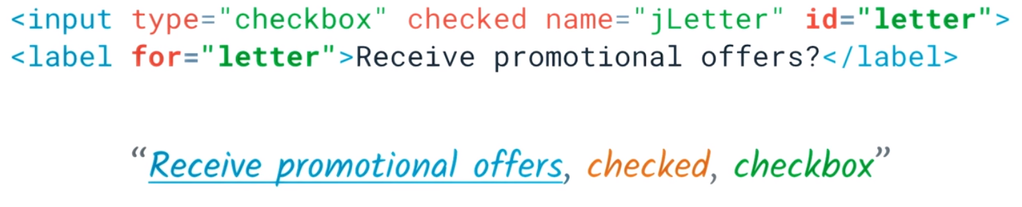

1. Quiz: Labeling Input Elements
2. Text Alternatives

Alt for images are important.

1. Quiz: Labeling Images With ALT Text

Leave alt text as alt="" for things that do not need explanation. All images should have them with details.

1. Lesson 3 Outro